DATA HANDLING AND VISUALIZATION ACTIVITIES
Activity 1: Heatmap – Student Performance Analysis
Student | Mathematics | Physics | Chemistry | Programming | English
S1 | 92 | 88 | 84 | 95 | 81
S2 | 76 | 72 | 69 | 80 | 74
S3 | 81 | 78 | 83 | 85 | 79
S4 | 65 | 70 | 68 | 72 | 75
S5 | 90 | 94 | 91 | 96 | 89
S6 | 58 | 62 | 60 | 65 | 70
S7 | 84 | 86 | 82 | 88 | 80
S8 | 71 | 75 | 73 | 77 | 72
S9 | 95 | 91 | 93 | 98 | 94
S10 | 79 | 81 | 77 | 83 | 78
1. Construct a Heatmap.
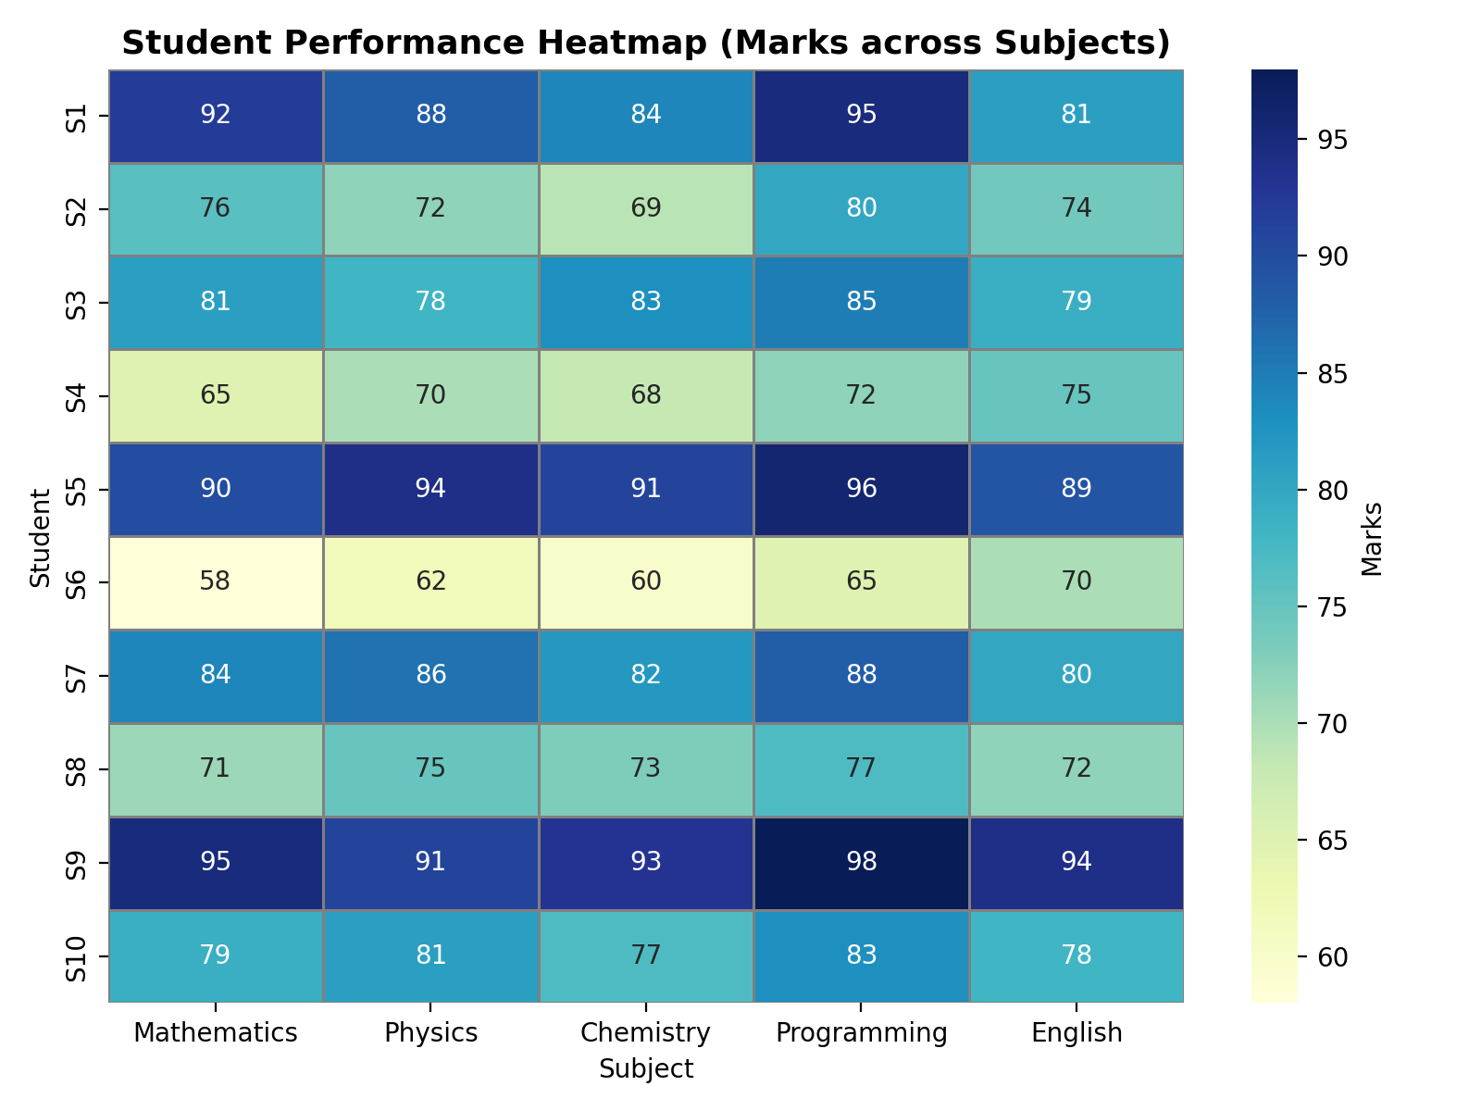
The heatmap shows marks of each student across five subjects using colour intensity, with darker shades indicating higher marks.
2. Identify highest overall performer.
Student averages: S1=88.0, S2=74.2, S3=81.2, S4=70.0, S5=92.0, S6=63.0, S7=84.0, S8=73.6, S9=94.2, S10=79.6.
S9 is the highest overall performer with an average score of 94.2 marks.
3. Find highest average subject.
Subject averages: Mathematics=79.1, Physics=79.7, Chemistry=78.0, Programming=83.9, English=79.2.
Programming has the highest average score of 83.9 marks.
4. Identify students needing support.
Using an overall average below 70 marks as the criterion, S6 needs support with an average of 63.0 marks.
5. Explain Heatmap advantages.
• Allows quick visual comparison of performance across many students and subjects.
• Colour intensity makes it easy to spot the highest and lowest scores instantly.
• Compact representation of a large dataset without reading every number.
Activity 2: Violin Plot & Boxplot – Employee Salary Analysis
Employee | HR | IT | Finance | Marketing
E1 | 4.2 | 6.5 | 5.8 | 5.1
E2 | 4.5 | 7 | 6.2 | 5.3
E3 | 4.7 | 7.4 | 6 | 5.5
E4 | 4.1 | 6.8 | 5.9 | 5.4
E5 | 4.6 | 8.2 | 6.7 | 5.8
E6 | 4.3 | 7.6 | 6.4 | 5.6
E7 | 4.8 | 8.5 | 6.9 | 5.9
E8 | 4.4 | 7.1 | 6.1 | 5.2
E9 | 4.9 | 8.8 | 7.2 | 6
E10 | 4.5 | 7.3 | 6.3 | 5.4
1. Draw violin plots.
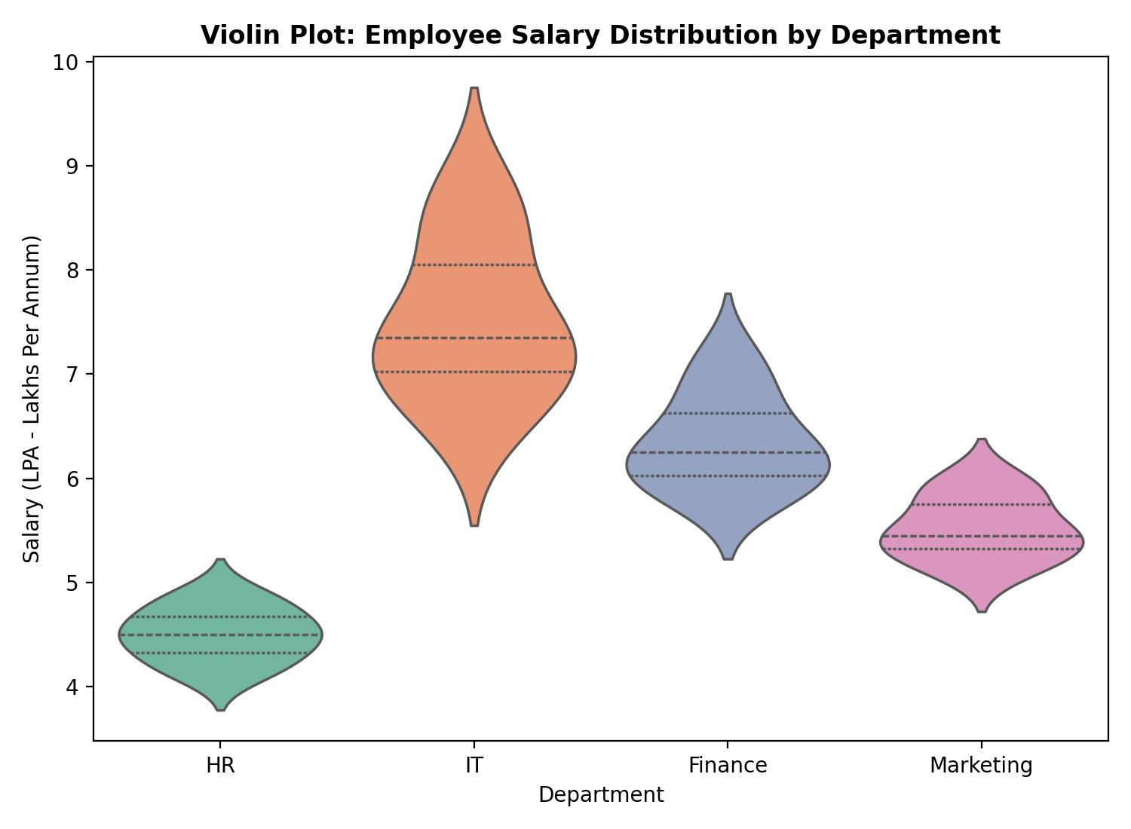
IT shows the highest and most spread-out salaries, while HR is the lowest and most tightly clustered.
2. Construct boxplots.
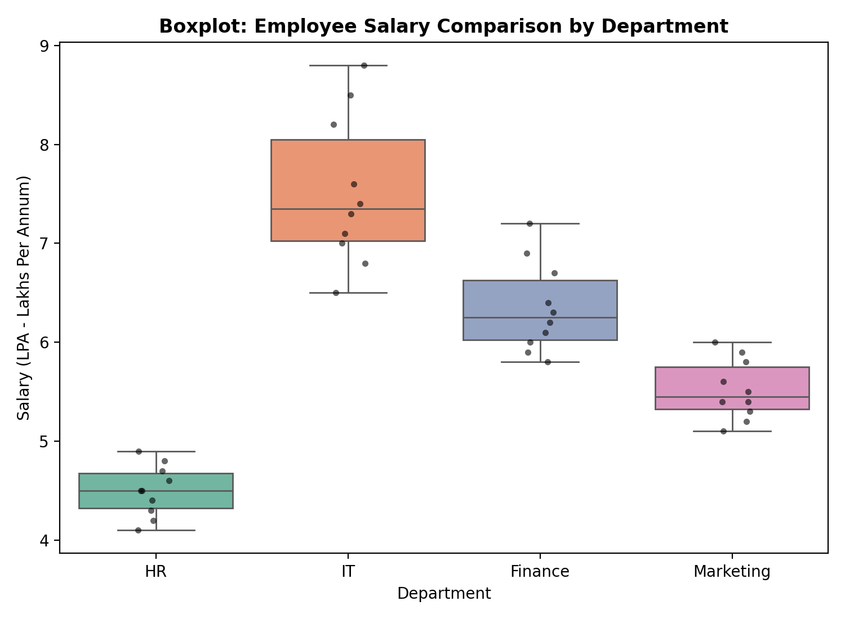
The boxplot confirms IT has the highest median and widest spread among the four departments.
3. Largest variation?
Std Dev / Range (LPA): HR=0.258/0.8, IT=0.755/2.3, Finance=0.455/1.4, Marketing=0.301/0.9.
IT has the largest variation, with standard deviation 0.755 LPA and range 2.3 LPA.
4. Highest median?
Median salary (LPA): HR=4.50, IT=7.35, Finance=6.25, Marketing=5.45.
IT has the highest median salary of 7.35 LPA.
5. Which plot better represents distribution?
The violin plot better represents the complete distribution shape since it also shows density, while the boxplot is simpler and better for quick comparison of medians and spread.
Activity 3: Histogram & Density Plot – Website Response Time
Obs | RT(ms) | Obs | RT(ms)
1 | 210 | 11 | 300
2 | 225 | 12 | 305
3 | 230 | 13 | 310
4 | 240 | 14 | 315
5 | 250 | 15 | 320
6 | 260 | 16 | 330
7 | 270 | 17 | 340
8 | 280 | 18 | 350
9 | 285 | 19 | 360
10 | 290 | 20 | 380
1. Draw histogram.
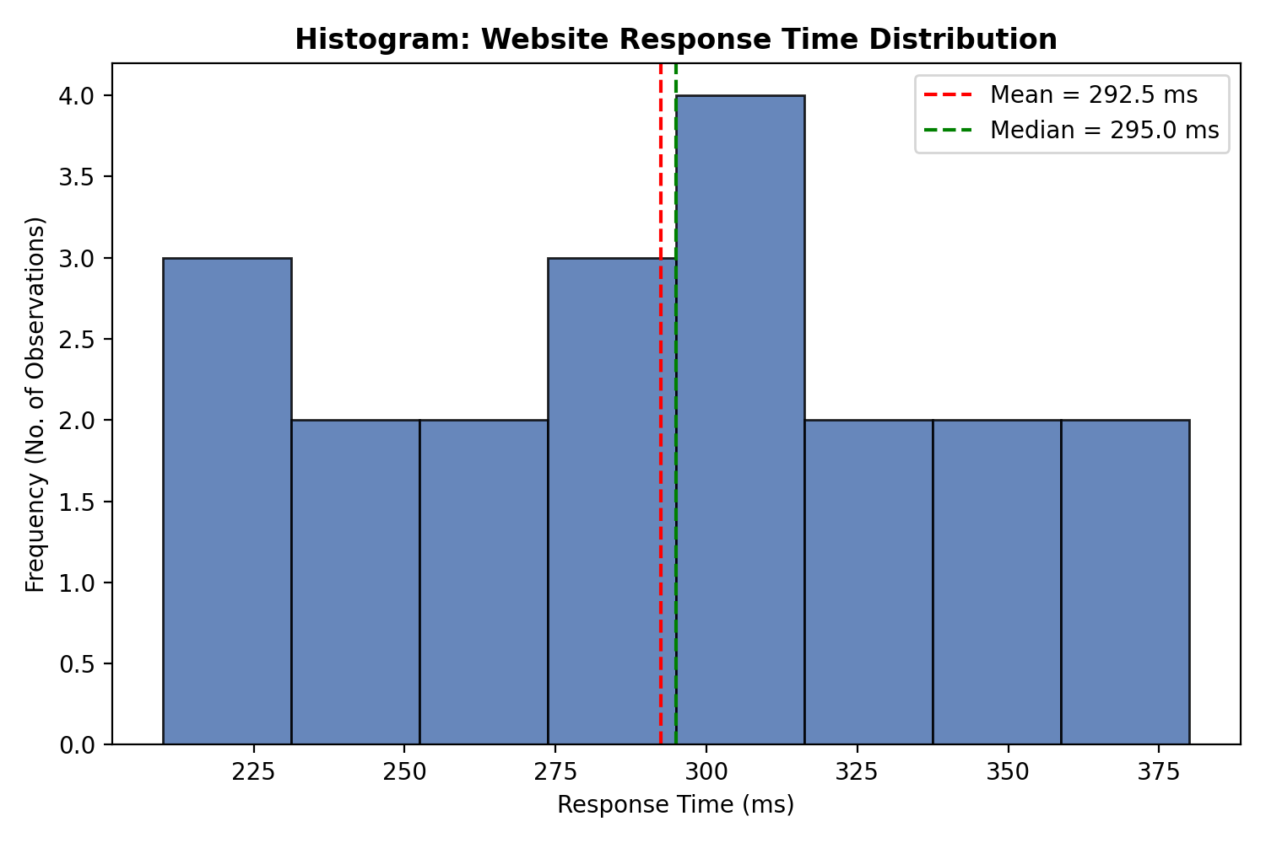
Response times are fairly evenly spread from 210 ms to 380 ms with no single bin dominating.
2. Plot density.
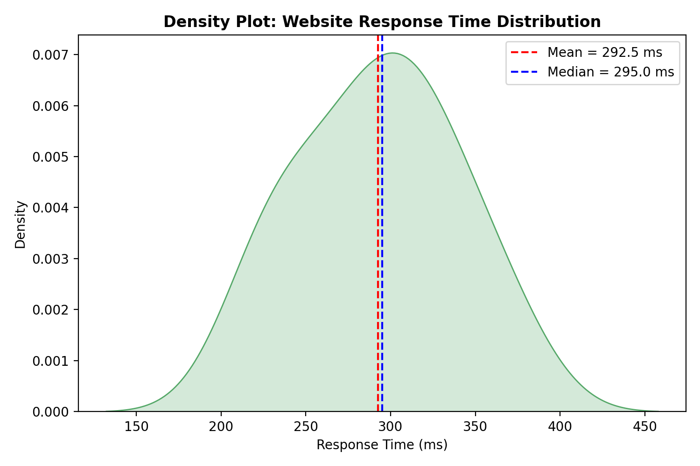
The density curve is broad and close to symmetric, confirming no sharp peak in response times.
3. Determine skewness.
Skewness = −0.008 (Mean = 292.5 ms, Median = 295.0 ms, Std Dev = 47.34 ms), indicating the distribution is approximately symmetric.
4. Common range.
Most response times are concentrated between 250 ms and 330 ms (Q1 = 257.5 ms, Q3 = 322.5 ms).
5. Which plot better represents distribution?
The density plot better represents the overall shape since it is smooth and independent of bin width, while the histogram is more useful for exact frequency counts.
Activity 4: Ridgeline Plot – Electricity Consumption
House | Jan | Feb | Mar | Apr | May
H1 | 220 | 235 | 250 | 275 | 295
H2 | 240 | 245 | 260 | 285 | 305
H3 | 230 | 238 | 255 | 280 | 300
H4 | 215 | 228 | 248 | 270 | 292
H5 | 225 | 240 | 258 | 282 | 298
H6 | 245 | 250 | 265 | 290 | 310
H7 | 235 | 242 | 259 | 284 | 302
H8 | 228 | 236 | 252 | 278 | 297
H9 | 238 | 246 | 262 | 287 | 307
H10 | 232 | 239 | 256 | 281 | 301
1. Create ridgeline plot.
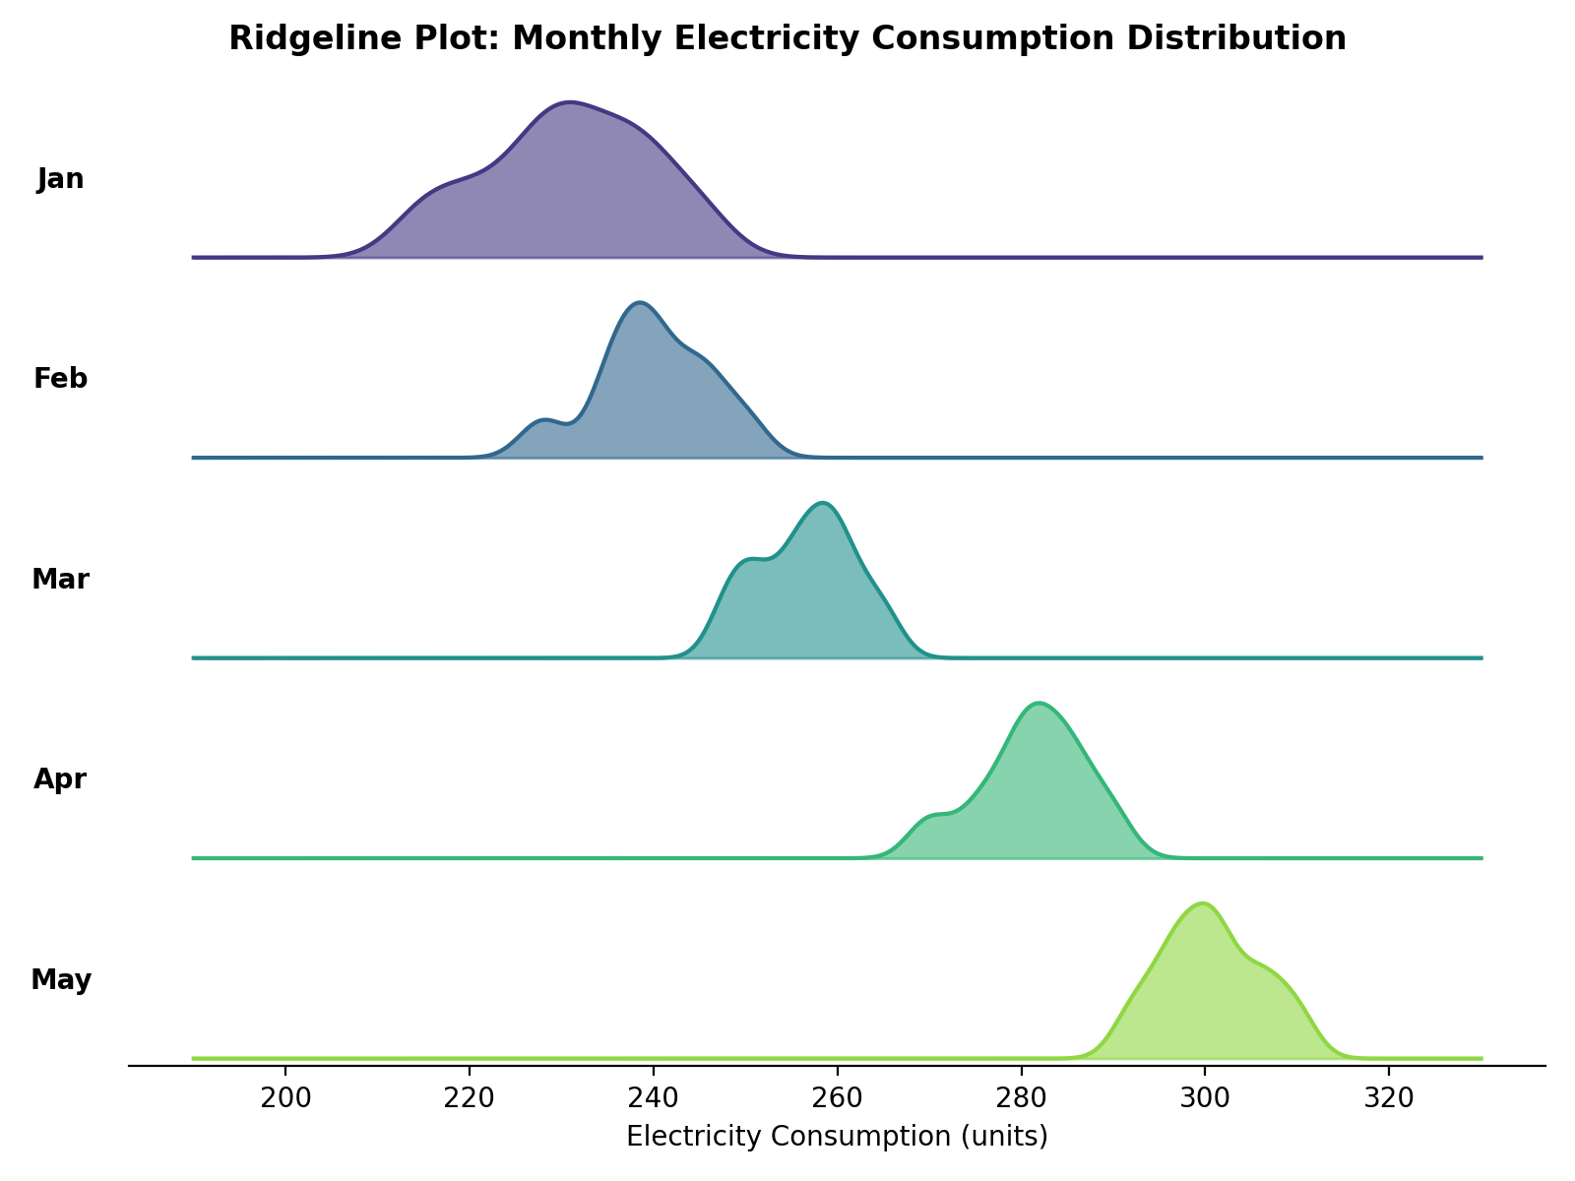
The ridgeline plot shows the monthly consumption distributions shifting steadily higher from January to May.
2. Highest average month?
Average consumption (units): Jan=230.8, Feb=239.9, Mar=256.5, Apr=281.2, May=300.7.
May has the highest average consumption at 300.7 units.
3. Widest spread?
Std Dev / Range (units): Jan=9.22/30, Feb=6.28/22, Mar=5.38/17, Apr=5.87/20, May=5.54/18.
January has the widest spread, with standard deviation 9.22 units and range 30 units.
4. Describe trend.
Electricity consumption shows a steady increasing trend from January to May. The average consumption rises from 230.8 units in January to 300.7 units in May, an increase of 69.9 units.
5. Why ridgeline?
A ridgeline plot allows several monthly distributions to be compared in one compact chart without overlapping confusingly. It clearly shows how consumption shifts progressively higher each month.
Activity 5: Histogram, Density & Boxplot – Daily Steps
Person | 20–30 | 31–45 | 46–60
P1 | 9500 | 8200 | 6500
P2 | 10200 | 8600 | 6700
P3 | 9800 | 8400 | 6900
P4 | 11000 | 9000 | 7200
P5 | 10500 | 8900 | 7000
P6 | 9700 | 8500 | 6800
P7 | 10100 | 8700 | 7100
P8 | 10800 | 9100 | 7300
P9 | 11200 | 9200 | 7400
P10 | 9900 | 8600 | 6950
1. Draw histograms.
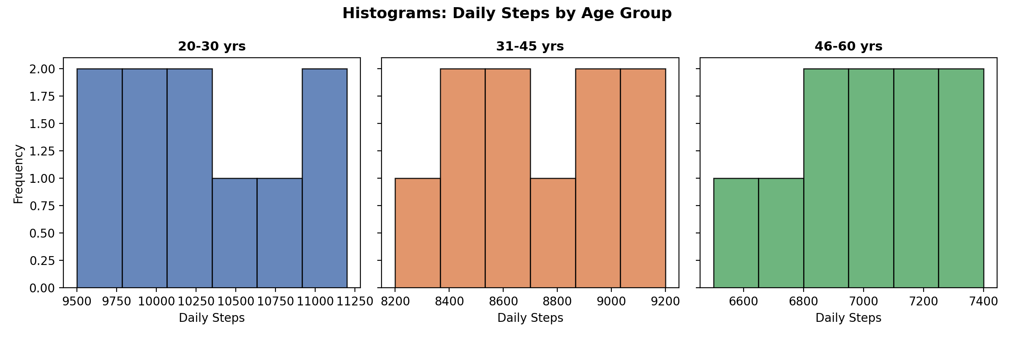
The 20–30 group shows the highest step counts, 31–45 is centred lower, and 46–60 has the lowest, shifting progressively leftward.
2. Plot density curves.
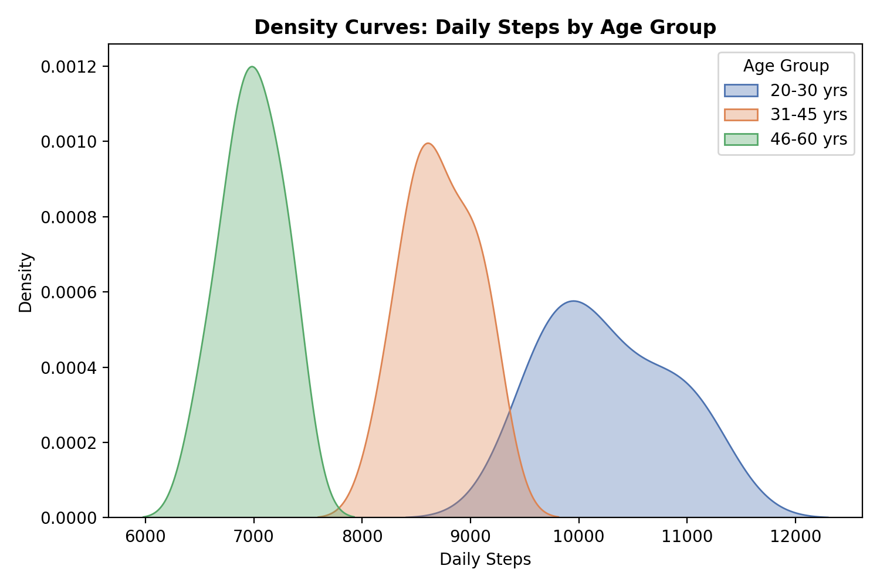
The density curves show three distinct, largely non-overlapping peaks, confirming decreasing activity levels with age.
3. Create boxplots.
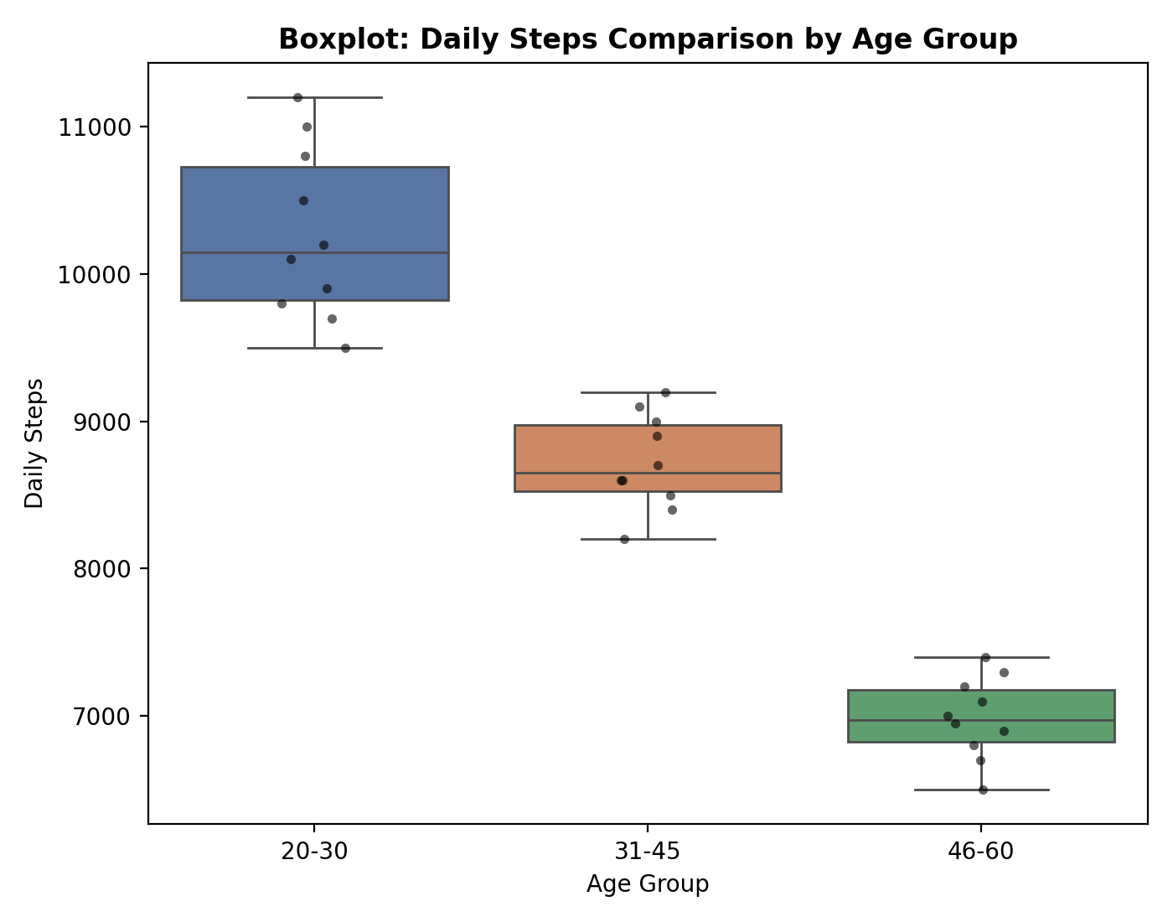
The boxplots confirm the median step count decreases progressively from the 20–30 group to the 46–60 group.
4. Highest median group?
Median daily steps: 20–30=10150, 31–45=8650, 46–60=6975.
The 20–30 age group has the highest median daily steps at 10,150 steps.
5. Best visualization and justify.
The boxplot is the best visualization for comparing the three groups, since it shows median, spread and outliers side by side in one compact view.

